Evaluation for Task 1

Task one was to simply allow a user to search for a word in a sentence. That alone is relatively simple, but it’s getting around making sure the user doesn’t create any errors that makes up most of the code.

My task successfully does this, allowing the user to input their own sentence of which they can check if a word Is in it, and if it is, it will tell them the position of that word whether it appeared once, or more than once.

In terms of difficulty, I would say this program was reasonably difficult considering all the checks you had to do on the inputs, and having to use the enumerate function to find out if the word appeared more than once in the same sentence. Also, I had to make sure there was no case sensitivity. Apart from that, the core of the program was easy.

Here’s a quick criteria check going back to the task analysis.

* Word input
* Sentence input
* Sentence to list transformation
* List positions using index
* 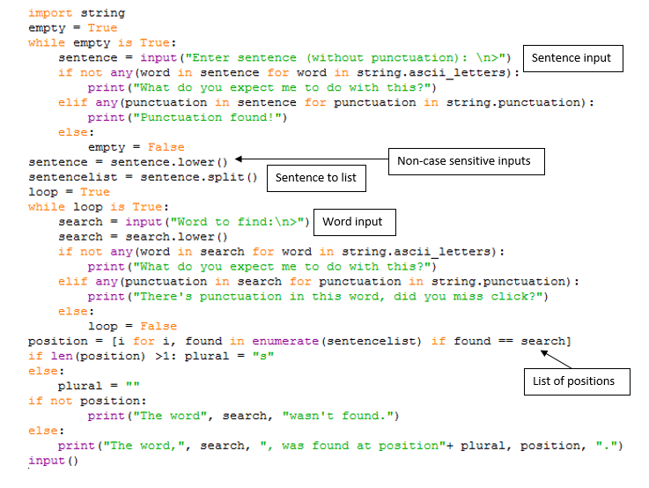Non-case sensitive inputs